Utkarsh Chaturvedi

# A0206518H



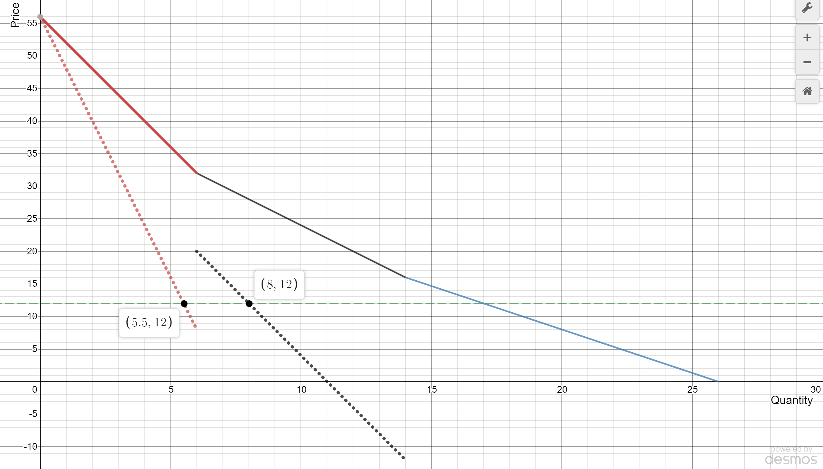



Graph plotted on: desmos.com

